ECON 101 – MACROECOMICS
Final Exam
EXAMINER: MUHEBULLAH KARIMZADA
April 18, 2026

Instructions:
1. You have 120 minutes to work on the exam.
2. This exam is individual and closed-book.
3. For the multiple-choice questions, choose the option that best answers/completes the question.
4. This Examination paper includes 18 pages (includes the cover page). You are responsible for ensuring that your copy of the paper is complete. Bring any discrepancy to the attentions of your invigilator.

PLEASE: PUT YOUR NAME AND STUDENT ID ON EVERY SHEET!!

Multiple Choice Answers:

1. _________ 17. _________ 33. _________ 49. _________ 65. _________

2. _________ 18. _________ 34. _________ 50. _________ 66. _________

3. _________ 19. _________ 35. _________ 51. _________ 67. _________

4. _________ 20. _________ 36. _________ 52. _________ 68. _________

5. _________ 21. _________ 37. _________ 53. _________ 69. _________

6. _________ 22. _________ 38. _________ 54. _________ 70. _________

7. _________ 23. _________ 39. _________ 55. _________ 71. _________

8. _________ 24. _________ 40. _________ 56. _________ 72. _________

9. _________ 25. _________ 41. _________ 57. _________ 73. _________

10. _________ 26. _________ 42. _________ 58. _________ 74. _________

11. _________ 27. _________ 43. _________ 59. _________ 75. _________

12. _________ 28. _________ 44. _________ 60. _________ 76. _________

13. _________ 29. _________ 45. _________ 61. _________ 77. _________

14. _________ 30. _________ 46. _________ 62. _________. 78. _________

15. _________ 31. _________ 47. _________ 63. _________ 79. _________

16. _________ 32. _________ 48. _________ 64. _________ 80. _________
MULTIPLE CHOICE. Choose the one alternative that best completes the statement or answers the question.

1) Arlene quits her $125,000-a-year job to take care of her ailing parents. What is the opportunity cost of her decision?
A) the value she attributes to the satisfaction she receives from taking care of her parents
B) It depends on the "going rate" for home-care providers.
C) zero, since she will no longer be earning a salary
D) at least $125,000
E) the total value of all alternatives that must be given up to engage in taking care of her parents

2) Economics is the study of the ________ people make to attain their goals, given their ________ resources.
A) purchases; unlimited
B) output; time
C) choices; scarce
D) decisions; household
E) income; available

Table 1.4
Hours  Open | Total Revenue  (dollars)
1 | $75
2 | 125
3 | 160
4 | 185
5 | 200
6 | 210

Sofia runs a small candy store. She is debating whether she should extend her hours of operation. Sofia figures that her sales revenue will depend on the number of additional hours the candy store is open as shown in the table above. She would have to hire a worker for those hours at a wage rate of $15 per hour.

3) Refer to Table 1.4. What is Sofia's marginal benefit if she decides to stay open for six hours instead of five hours?
A) $10 B) $15 C) $25 D) $210

4) Fiona shares an office with her ex-husband. Her share of the rent and utilities is $625 per month. She is considering moving to a home office which she will not have to share with anyone. The home office will not cost her anything as far as extra rent or utilities. Recently, you ran into Fiona at the gym and she tells you that she has moved into her home office. Fiona is as rational as any other person. As an economics major, you rightly conclude that

A) Fiona did not have a choice; her ex-husband was a jerk.
B) the cost of having one's own space outweighs the benefits.
C) Fiona figures that the benefit of having her own office (as opposed to sharing) is zero, since she is no longer paying rent and utilities.
D) Fiona figures that the additional benefit of having her own office (as opposed to sharing) is at least $625.

5) DeShawn's Detailing is a service that details cars at the customers' homes or places of work. DeShawn's cost for a basic detailing package is $40, and he charges $75 for this service. For a total price of $90, DeShawn will also detail the car's engine, a service that adds an additional $20 to the total cost of the package. Should DeShawn continue to offer the engine detailing service?
A) Yes, he still makes a profit by selling the engine detailing service with the basic detailing package.
B) Yes, because he will increase sales of the basic detailing package.
C) Yes, but only if he raises the price of the basic detailing package.
D) No, his marginal benefit is less than his marginal cost.
E) More information is needed for DeShawn to make this decision.

6) Households
A) purchase final goods and services in the factor market.
B) purchase resources in the factor market.
C) purchase final goods and services in the product market.
D) have no influence on the circular flow in a market economy.
E) purchase resources in the product market.

7) The resource income earned by those who supply ________ is called wages.
A) land
B) labour
C) entrepreneurship
D) equipment
E) capital

8) If the production possibilities frontier is ________, then opportunity costs are constant as more of one good is produced.
A) bowed in B) bowed out C) vertical D) linear E) nonlinear

Figure 2.14

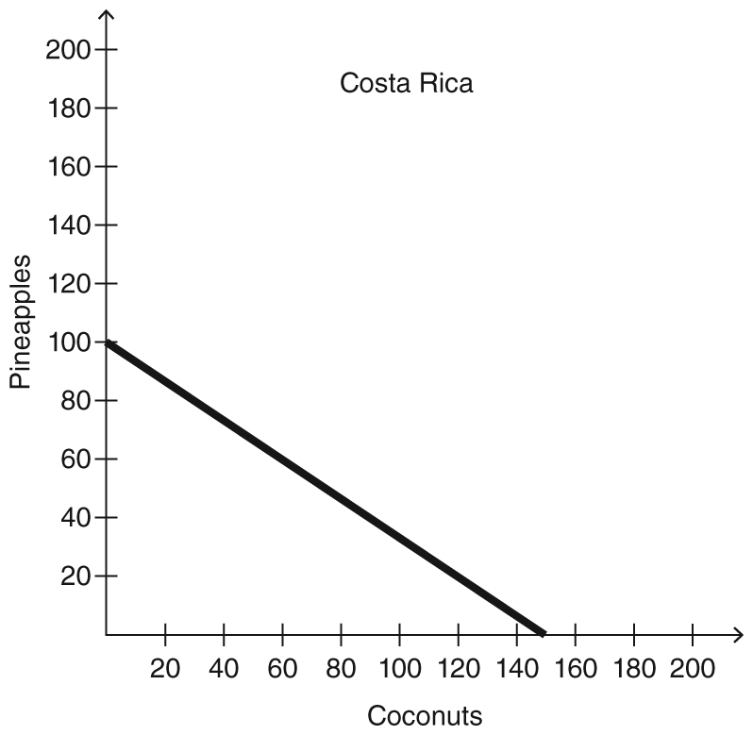
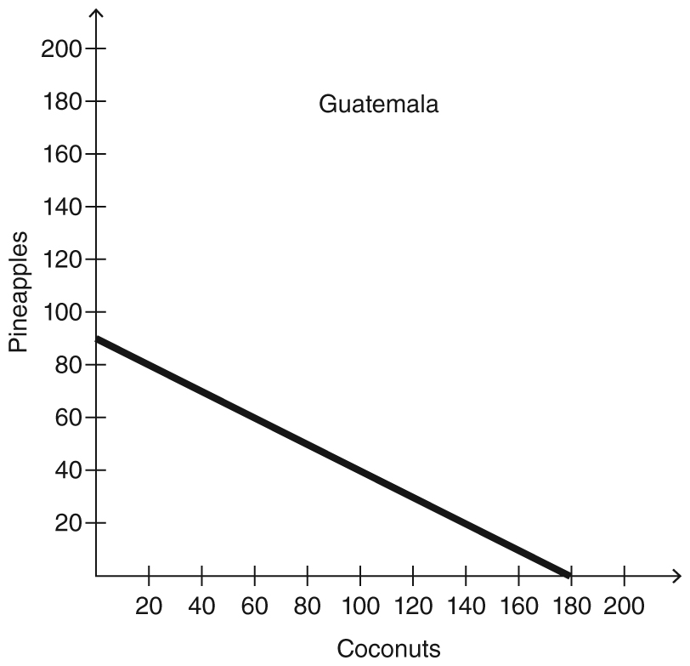

Figure 2.14 shows the production possibilities frontiers for Costa Rica and Guatemala. Each country produces two goods, pineapples and coconuts.

9) Refer to Figure 2.14. Which country has a comparative advantage in the production of coconuts?
A) Costa Rica
B) Guatemala
C) Neither country has any productive abilities.
D) Both countries have equal productive abilities.
E) Cannot be determined.

Figure 2.13

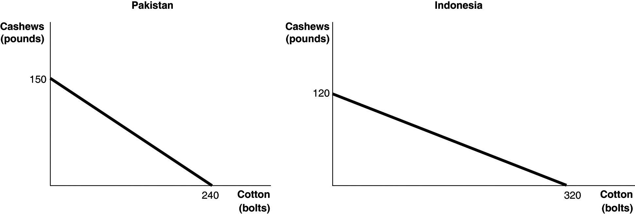

Figure 2.13 shows the production possibilities frontiers for Pakistan and Indonesia. Each country produces two goods, cotton and cashews.

10) Refer to Figure 2.13. What is the opportunity cost of producing 1 bolt of cotton in Pakistan?
A) 3/8 of a pound of cashews
B) 5/8 of a pound of cashews
C) 1 3/5 pounds of cashews
D) 150 pounds of cashews
E) 240 pounds of cashews

Figure 2.12

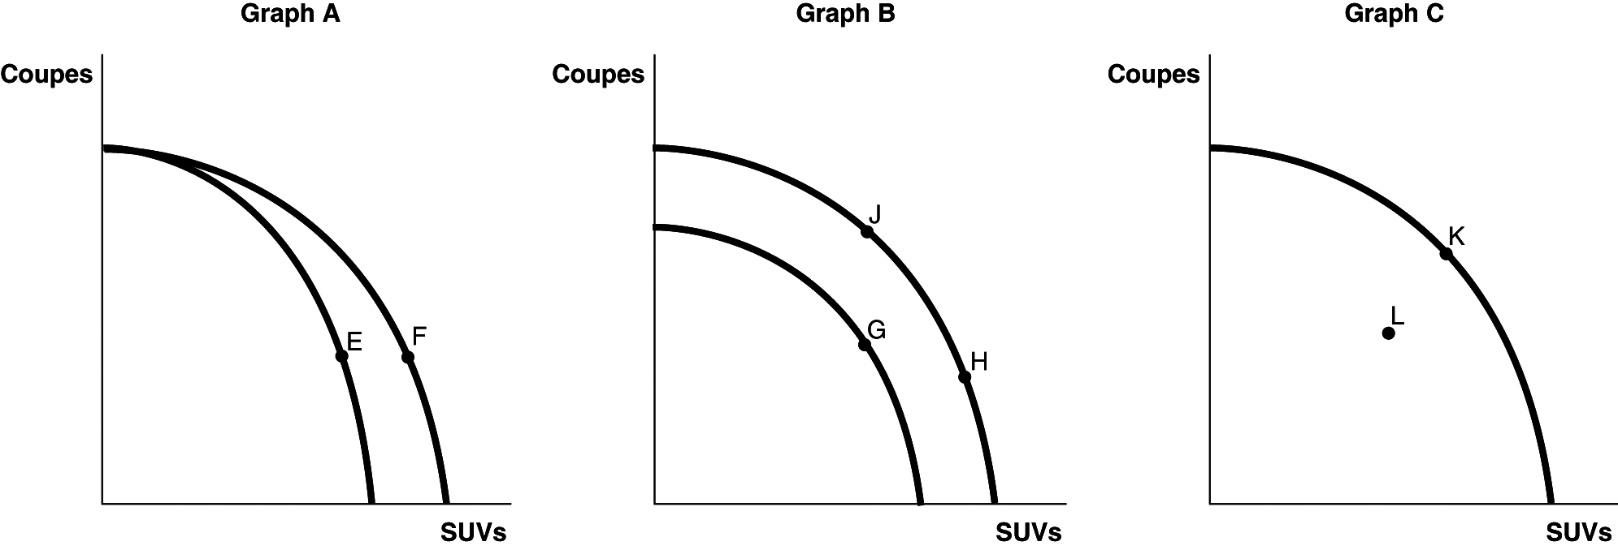

Tesla motors currently has three different models available in Canada; the Model S and the Model 3 (both coupes) and the Model X (an SUV). Figure 2.12 shows changes to its production possibilities frontier in response to new developments and different strategic production decisions.

11) Refer to Figure 2.12. In response to changing consumer demands, Tesla cuts back on the production of coupes and increases its production of SUVs. This strategy is best represented by
A) movement from E to F in Graph A.
B) movement from G to H in Graph B.
C) movement from J to H in Graph B.
D) movement from H to J in Graph B.
E) movement from K to L in Graph C.
Figure 3.13

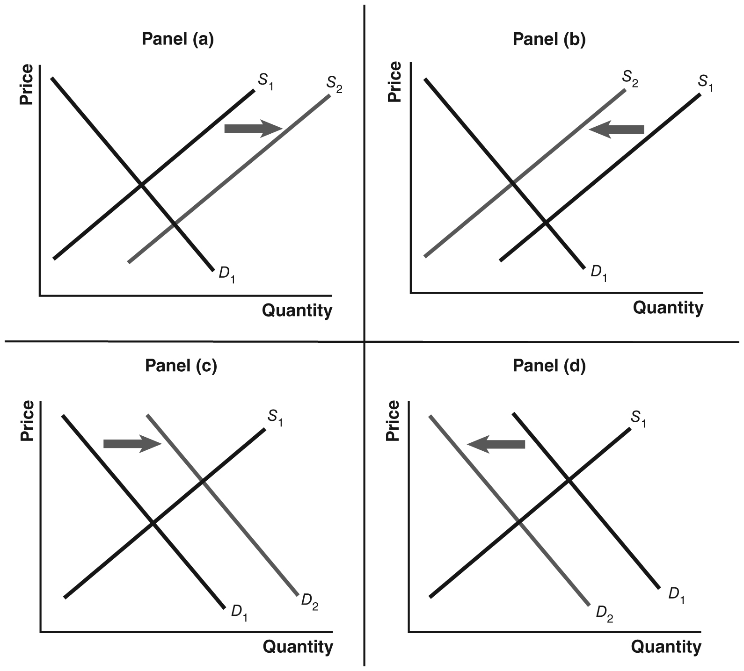

12) Refer to Figure 3.13. Assume that the graphs in this figure represent the demand and supply curves for used clothing, an inferior good. Which panel describes what happens in this market as a result of a decrease in income?
A) Panel (a)
B) Panel (b)
C) Panel (c)
D) Panel (d)
E) Panels (a) and (b)

Figure 3.3

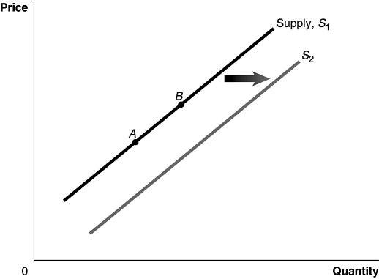

13) Refer to Figure 3.3. An increase in price of inputs would be represented by a movement from
A) A to B. B) B to A. C) S1 to S2. D) S2 to S1. E) 0 to A.

14) If Canada bans the importation of beluga caviar from the Caspian Sea, what happens in the market for caviar in Canada?
A) The demand curve shifted to the left.
B) The supply curve shifted to the right.
C) The demand curve shifted to the right.
D) The supply curve shifted to the left.
E) The supply and demand curves are unchanged.

Figure 3.13



15) Refer to Figure 3.13. Assume that the graphs in this figure represent the demand and supply curves for rice. What happens in this market if buyers expect the price of rice to fall?
A) Panel (a)
B) Panel (b)
C) Panel (c)
D) Panel (d)
E) Panels (b) and (c)

16) Factory incentives on cell phones have encouraged consumers to upgrade their phones. How does this affect the market for Bluetooth headsets?
A) It increases demand for Bluetooth headsets.
B) It does not change demand for Bluetooth headsets.
C) It decreases demand for Bluetooth headsets.
D) It decreases the quantity of Bluetooth headsets demanded.
E) It increases the quantity of Bluetooth headsets demanded.

17) In January, buyers of gold expect that the price of gold will rise in February. What happens in the gold market in January, holding all else constant?
A) The supply curve shifts to the right.
B) The demand curve shifts to the left.
C) The demand curve shifts to the right.
D) The quantity demanded increases.
E) The supply and demand curves will remain unchanged.

18) The GDP deflator is the
A) difference between real GDP and nominal GDP multiplied by 100.
B) difference between real GDP minus potential GDP multiplied by 100.
C) difference between nominal GDP and real GDP multiplied by 100.
D) ratio of real GDP to nominal GDP multiplied by 100.
E) ratio of nominal GDP to real GDP multiplied by 100.

19) To calculate GDP using the value-added method, one would add up
A) only the value added by the underground economy.
B) the market value of final goods and services produced during a particular period.
C) the value added by each firm involved in the production of final goods and services.
D) the after tax profits of every firm in the economy.
E) the market value of intermediate goods and services produced during a particular period.

20) Which of the following would increase disposable personal income?
A) a decrease in personal income
B) a decrease in interest payments
C) a decrease in transfer payments received
D) a decrease in taxes paid
E) All of the above would increase disposable income.

21) Gross domestic product is calculated by summing up
A) the total quantity of goods and services produced in the economy during a period of time.
B) the total market value of final goods and services produced in the economy during a period of time.
C) the total value of all goods and services produced by a countries people during a period of time.
D) the total quantity of goods and services in the economy.
E) the total market value of goods and services in the economy.

Table 4.15
Year | Nominal GDP | Real GDP
2020 | $13,399 | $12,976
2021 | 14,078 | 13,254
2022 | 14,441 | 13,312

22) Refer to Table 4.15. Consider the data shown above on nominal GDP and real GDP (values are in billions of dollars). The GDP deflator for 2021 equals
A) 94.1. B) 105.1. C) 106.2. D) 108.5. E) 127.2.
23) The recession that followed the global financial crisis of 2007-2009 caused ________ in Canada.
A) a drop in the working age population
B) less unemployment
C) an increase in the duration a typical unemployed person was out of work
D) a rise in the labour force participation rate
E) less government spending

24) The labour force equals the number of people
A) in the working-age population.
B) employed plus unemployed.
C) employed.
D) unemployed.
E) in the entire country.

25) When an economy is at its natural rate of unemployment, which of the following will be true?
A) The employment population ratio will be 80%.
B) The unemployment rate will be 0%.
C) The labour force participation rate will be 100%.
D) The unemployment rate will be greater than 0%.
E) Only structural unemployment as a result of technological change will exist in the economy.

26) If we want to use a measure of inflation that foreshadows price changes before they affect prices at the retail level, we would base our measure of inflation on
A) the Baltic dry index.
B) the consumer price index.
C) the producer price index.
D) the household price index.
E) the GDP deflator.

27) You borrow $10,000 from a bank for one year at a nominal interest rate of 5%. If inflation over the year is 2%, what is the real interest rate you are paying?
A) 2% B) 2.5% C) 3% D) 5% E) 7%

Table 5.18
Year | Nominal Average  Hourly Earnings | CPI  (2002 = 100)
2020 | $25.11 | 126.6
2021 | 25.48 | 128.1
2022 | 25.90 | 131.2

28) Refer to Table 5.18. Looking at the table above, real average hourly earnings between 2020 and 2021 changed by
A) 0.3%. B) 1.5%. C) 2.2%. D) 5%. E) 6.5%.

29) The demand for loanable funds has a ________ slope because the lower the interest rate, the ________ the number of profitable investment projects, and the ________ the quantity of loanable funds demanded.
A) positive; lower; lower
B) negative; greater; lower
C) negative; lower; lower
D) negative; lower; greater
E) negative; greater; greater

30) When a recession ends,
A) interest rates decrease.
B) firms increase the amount of borrowing.
C) households demand fewer products of all categories.
D) the household sector decreases spending substantially.
E) households decrease spending on durable goods.

31) Ebenezer Scrooge's (the main character in Charles Dickens' A Christmas Carol) change in behaviour from miser to spender might actually be detrimental to the economy because
A) Scrooge's consumption habits were more detrimental to the environment than were his earlier saving habits.
B) saving has to be greater than consumption for the economy to grow.
C) Scrooge was happiest when he was saving money, and happiness is the key to economic growth.
D) Scrooge's spending is likely to reduce the demand for loanable funds.
E) Scrooge's miserly saving helped contribute to the production of investment goods rather than consumption goods.

32) In 2021, Norway had a budget surplus of approximately $16 billion. This meant
A) G > TR. B) G -TR > T. C) G < T. D) T + TR < G. E) T - TR < G.

33) If real GDP in a small country in 2021 is $8 billion and real GDP in the same country in 2022 is $8.3 billion, the growth rate of real GDP between 2021 and 2022 is
A) -3.0%. B) 3.0%. C) -3.6%. D) 3.6%. E) 3.75%.

34) Which of the following would encourage economic growth through increases in the capital stock?
A) a decrease in the government deficit
B) a change from an income tax to a consumption tax
C) an increase in household saving
D) all of the above
E) none of the above

35) If the growth rate of real GDP rises from 3% to 4% per year, then the number of years required to double real GDP will decrease from
A) 11.2 years to 10.8 years.
B) 23.3 years to 17.5 years.
C) 30.4 years to 23.5 years.
D) 28.0 years to 21.0 years.
E) 23.3 years to 20.6 years.

36) An unplanned decrease in inventories results in
A) an increase in unemployment.
B) an increase in planned investment.
C) actual investment that is greater than planned investment.
D) a decrease in planned investment.
E) actual investment that is less than planned investment.

37) The formula for aggregate expenditure is
A) AE = C + I + depreciation - NX.
B) AE = C + I - depreciation + NX.
C) AE = C + I + G.
D) AE = C + I + G - NX.
E) AE = C + I + G + NX.

38) In 2007-2008, exports from Canada to the United States fell dramatically. Based on the multiplier effect, we would expect
A) the economy to grow by less than the drop in exports.
B) the economy to shrink by less than the drop in exports.
C) the economy to shrink by more than the drop in exports.
D) the economy to grow by more than the drop in exports.
E) the economy to be unaffected due to a corresponding drop in imports.

39) If the consumption function is defined as C = 5,500 + 0.9Y, what is the value of the multiplier?
A) 0.1 B) 0.9 C) 2 D) 9 E) 10

40) Which aggregate supply curve has a positive slope?
A) long run only
B) short run only
C) neither long run nor short run
D) neither, both long run and short run are perfectly vertical
E) neither, both long run and short run are perfectly horizontal

41) If technological change occurs in the economy,
A) the long-run aggregate supply curve will become steeper.
B) the long-run aggregate supply curve will shift to the left.
C) we will move down along the long-run aggregate supply curve.
D) the long-run aggregate supply curve will shift to the right.
E) we will move up along the long-run aggregate supply curve.
42) The long-run adjustment to a negative supply shock results in
A) aggregate demand shifting to the left.
B) the short-run aggregate supply curve shifting to the right.
C) workers being willing to accept higher wages.
D) unemployment rising.
E) the price level rising.

43) Suppose the economy is at a short-run equilibrium GDP that lies above potential GDP. Which of the following will occur because of the automatic mechanism adjusting the economy back to potential GDP?
A) Prices will decline.
B) Wages will rise.
C) Unemployment will decline.
D) The exchange rate will rise.
E) Output will increase.

Figure 9.1

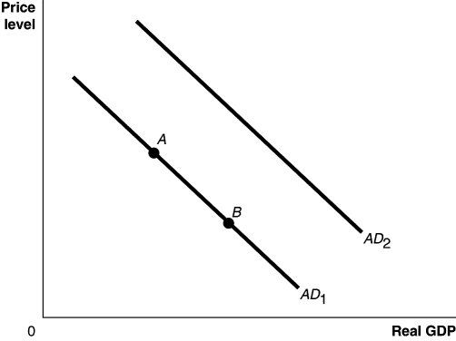

44) Refer to Figure 9.1. Ceteris paribus, a decrease in the growth rate of domestic GDP relative to the growth rate of foreign GDP would be represented by a movement from
A) AD1 to AD2.
B) AD2 to AD1.
C) point A to point B.
D) point B to point A.
E) point 0 to point A.

45) Commodity money
A) has value independent of its use as money.
B) is backed by a valuable commodity such as gold.
C) diminishes the long-term value of money.
D) has little to no value independent of its use as money.
E) can be used to purchase commodities, but not services.

46) Which of the following is not a major function of the Bank of Canada?
A) setting income tax rates
B) clearing cheques between banks
C) controlling the money supply
D) managing the funds of the federal government
E) acting as lender of last resort

47) If banks closed and ATMs limited withdrawals to 3 a week and no more than $100 per withdrawal, what would be the most likely result?
A) Businesses would start to demand payment in cash.
B) A rapid growth in the economy as people began to trade more directly with each other.
C) Consumers would lose all incentive to hold cash.
D) Governments would start to refuse payment of taxes in cash.
E) Importers would make expanded use of credit.

48) According to the quantity theory of money, if the money supply grows at 6%, real GDP grows at 2%, and the velocity of money is constant, then the inflation rate will be
A) 12%. B) 8%. C) 6%. D) 4%. E) 2%.

49) When banks gain ________, they can ________ their loans; and the money supply ________.
A) reserves; increase; contracts
B) deposits; reduce; expands
C) withdrawals; increase; expands
D) reserves; increase; expands
E) withdrawals; decrease; expands

50) If the desired reserve ratio is 5 percent, then the simple deposit multiplier is
A) 1.05. B) 2. C) 5. D) 10. E) 20.

51) Banks keep ________ of chequing deposits as reserves because on a typical day withdrawals ________ deposits.
A) less than 100%; are much greater than
B) exactly 100%; are much greater than
C) more than 100%; are much greater than
D) less than 100%; are about the same as
E) exactly 100%; are about the same as

52) Your roommate argues that he can think of no better situation than living in a deflationary economy because prices of goods and services would continuously fall. You disagree and argue that during a deflation, people can be made worse off because
A) the purchasing power of people's incomes would increase.
B) the value of taxes collected by government will fall.
C) the value of the real interest rate will drop below the nominal interest rate.
D) the purchasing power of the currency would decrease.
E) borrowers will have to pay increasing amounts in real terms over time.
53) The body that is responsible for dating the beginning and ending dates for a recession is
A) Statistics Canada.
B) the Bank of Canada.
C) Canadian Parliament.
D) the Association of Chief Economics of Canadian Banks.
E) There is no such body in Canada.

54) Why would businesses watch the Bank of Canada for signs of changing interest rates?
A) Many consumers base their expectations of future income on the Bank of Canada's policy announcements.
B) Changes in the Bank of Canada's key policy rate determine the cost of the labour.
C) Many consumers borrow heavily to finance durable products, sales of these goods are likely to rise when the Bank of Canada lowers the interest rate.
D) Changes in Bank of Canada policy determine the federal income tax rate.
E) Changes in the Bank of Canada's key policy rate are good indicators of federal government spending decisions.

55) The Bank of Canada promptly cut the interest rate at the beginning of the 2007-2009 global financial crisis, even though the recession did not actually begin until some months later. Which of the following is the rationale for this action?
A) Rising growth rates over time mean recessions are not as steep as time moves on.
B) A new policy must be quickly implemented to do good.
C) The Bank of Canada was focused on the rising value of the Canadian dollar at the time.
D) The Bank of Canada inadvertently engaged in a procyclical policy as opposed to countercyclical policy.
E) Inaccurate Statistics Canada data was analyzed by the Bank of Canada's economists, which showed the recession was already underway.

56) Prior to 1970, mortgages were ________ resold in the secondary market.
A) never B) always C) rarely D) occasionally E) often

Figure 11.9

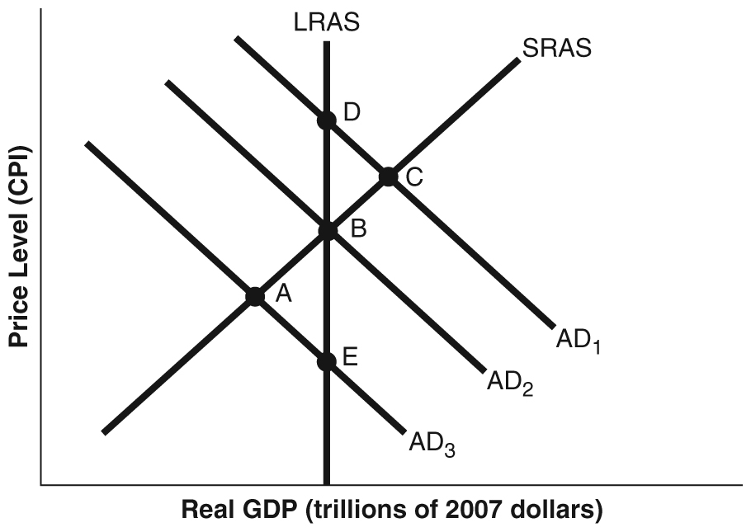

57) Refer to Figure 11.9. Suppose the economy is in short-run equilibrium above potential GDP, the unemployment rate is very low, and wages and prices are rising. Using the static AD-AS model in the figure above, the correct Bank of Canada policy for this situation would be depicted as a movement from
A) A to E. B) C to D. C) A to B. D) C to B. E) B to C.

58) The Bank of Canada uses the rate of change in the CPI rather than the GDP deflator to measure inflation because
A) the GDP deflator is more prone to biases and error than the CPI.
B) the CPI is a more accurate reflection of the inflation faced by households than the GDP deflator.
C) the CPI includes the prices of goods but not services.
D) the CPI is easier to calculate than the GDP deflator.
E) the GDP deflator lacks the information on inflation in the price of industrial equipment and other goods not found in the CPI.

59) The Taylor Principle states a central bank should raise the nominal interest rate by ________ the increase in the inflation rate so that the real interest rate ________.
A) an amount equal to; stays stable
B) more than; decreases
C) more than; also increases
D) less than; increases
E) less than; also decreases

60) The smaller the fraction of an investment financed by borrowing,
A) the greater the leverage and the greater the potential loss.
B) the smaller the potential return and the greater the potential loss on that investment.
C) the smaller the potential return and potential loss on that investment.
D) the greater the potential return and the smaller the potential loss on that investment.
E) the greater the potential return and potential loss on that investment.

61) If the Bank of Canada pursues expansionary monetary policy,
A) aggregate demand will rise and the price level will fall.
B) aggregate demand will fall and the price level will fall.
C) aggregate demand will be unchanged but the price level will fall.
D) aggregate demand will rise and the price level will rise.
E) aggregate demand will fall and the price level will rise.

62) Firms that participate in regular open market transactions with the U.S. Federal Reserve are called
A) reserve banks.
B) Federal Reserve partners.
C) secondary market banks.
D) Treasury banks.
E) primary dealers.

63) A(n) ________ in private expenditures as a result of ________ in government purchases is called crowding out.
A) increase; no change
B) increase; an increase
C) decrease; an increase
D) increase; a decrease
E) decrease; a decrease

64) The federal government debt as a percentage of GDP did not rise
A) during the 1960s.
B) during the Global Financial Crisis.
C) during the 1980s.
D) during late 1990s and early 2000s.
E) from 2009 to 2016.

65) Which of the following is not an option for provincial governments facing rising health care costs?
A) printing more money
B) increasing spending on health care services provided
C) reducing the level of health care services provided
D) reducing funding to education and other programs
E) raising income and sales taxes

66) Research by Christopher Ruhm shows that people's health ________ on average during an economic ________.
A) improves; recession
B) improves; expansion
C) stays the same; expansion
D) gets worse; recession
E) gets worse; expansion

67) Assume that in 2021 aggregate demand in Canada begin to grow much faster than aggregate supply. What policy would you recommend to Parliament?
A) There should be a decrease in government spending.
B) Income taxes should be lowered to reduce the federal budget surplus and raise interest rates.
C) The Bank of Canada should raise its target for the target for the overnight rate.
D) Local governments should increase spending on water treatment systems to offset the damage of extra economic activity on the environment.
E) Provincial governments should increase health care spending.

68) Crowding out will be greater
A) the less sensitive consumption spending is to changes in the interest rate.
B) the more sensitive consumers are to changes in the tax rate.
C) the more sensitive investment spending is to changes in the interest rate.
D) if the economy is in recession, rather than at full employment.
E) the further equilibrium GDP is below potential GDP.

69) Which of the following is an example of discretionary fiscal policy?
A) a decrease in employment insurance payments during an expansion or boom
B) tax cuts passed by the government to combat a recession
C) an increase in employment insurance payments during a recession
D) an increase in income tax receipts with rising income during an expansion
E) the replacement of the sewer system after a major sewerline break

70) Government deficits tend to increase during
A) periods immediately following elections.
B) periods of war and recession.
C) recessions and booms.
D) periods of increased financial uncertainty.
E) periods of below- or above-average growth.

71) Suppose real GDP is $1.6 trillion and potential GDP is $1.4 trillion. To move the economy back to potential GDP, the federal government should
A) lower taxes by $200 billion.
B) lower government purchases by an amount less than $200 billion.
C) raise taxes by an amount more than $200 billion.
D) lower government purchases by $200 billion.
E) raise taxes by $200 billion.

72) Some economists argue that the federal government should normally run a deficit at potential GDP, with the borrowed funds applied to
A) investment goods.
B) health care costs.
C) consumption goods.
D) social security benefits.
E) imported goods.

73) Expansionary fiscal policy to prevent real GDP from falling below potential real GDP would cause the inflation rate to be ________ and real GDP to be ________.
A) higher; higher
B) lower; higher
C) higher; lower
D) lower; lower
E) higher; unchanged

74) The austerity plan required of the Greek government is a(n) ________ policy, when normally a recession would suggest ________ policy.
A) expansionary; pro-cyclical
B) contractionary; contractionary
C) contractionary; cyclically adjusted
D) contractionary; expansionary
E) expansionary; contractionary

75) One desirable outcome of a market economy is that it leads to a more equitable distribution of income.
A) True
B) False

76) In a two-good, two-country world, if one country has an absolute advantage in the production of both goods, it can still benefit by trading with the other country.
A) True
B) False

77) If the population increases and input prices increase, the equilibrium price of a product will definitely increase.
A) True
B) False

78) The real-world money multiplier is greater than the simple money multiplier (1/rd).
A) True
B) False

79) If the rate of growth in real GDP exceeds the rate of growth in the money supply, the quantity theory of money predicts inflation.
A) True
B) False

80) Buying a house during a recession may be a good idea if your job seems secure because the Bank of Canada often lowers interest rates during a recession.
A) True
B) False

